QUESTION INTONATION

There are two general types of question intonation in English. First, there are wh-questions. These questions ask for information and go down at the end. Second, there are yes/no questions. These go up at the end.
Listen as I read the two sample questions and listen to how my voice follows the drawing above the question.
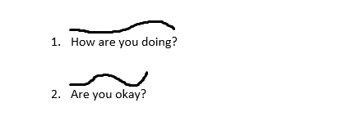

Now, listen to the second audio. Draw your own intonation lines as you hear them. When you are finished, check your answers against the answer key on page two.

- Are you excited?

- What’s up?

- What’s wrong?

- Is something wrong?

- Will you be at the party tonight?

- Do you like reading?

ANSWER KEY
