COMBINING EVERYTHING

Layer by layer, let’s analyze the following paragraphs. Let’s consider:
- Sounds
- Syllables
- Focus words
- Intonation
- Thought groups

As you analyze, follows these steps:
- Make the sounds (p, b, f, sh) and consonant clusters (th, ch) that need special attention red.
- Break the words in syl-la-bles. Underline the stressed syllable.
- Break the sentence into thought groups, with / for short pauses and // for long pauses.
- Highlight the focus word in each thought group.
- Draw a line showing the intonation in any questions.

These websites can help you.
- Find the stressed syllable: https://learnersdictionary.com/
- Find how many syllables: https://www.howmanysyllables.com/

Below is an example of a completely analyzed paragraph. Listen to the audio as you read along.

What do you want to do today? We could go to the beach – it is so beautiful out.
I want to go fishing.
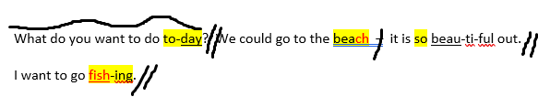
Your turn! Listen and analyze:

- I think learning an additional language is something everyone should do. It helps us communicate, but it also helps us learn a new perspective and make friends. Do you agree?

- When did you start learning English? It can be easier if you start young, but it is still possible to learn as an adult.

